The Sakila Movie Rental Database is a comprehensive sample database designed to simulate a movie rental store, offering insights into customer behavior, film popularity, and operational efficiency. It supports business intelligence and strategic decision-making by analyzing rental trends, financial performance, and inventory management.

**Sakila Movie Rental Analysis**

***Safyan Shahzeel***

**Overview:**

The primary objective of this project is to create a comprehensive Power BI dashboard using the Sakila Movie Rental Database. The analysis aims to provide valuable insights into the rental store business, focusing on customer behavior, film inventory management, staff performance, and store operations. The ultimate goal is to enable data-driven decision-making to improve overall business performance.

**THE PROCESS**

• **Define Objectives and Goals:**

* **Objective:** Create a comprehensive Power BI dashboard for the Sakila Movie Rental to provide insights into customer behavior, film inventory management, staff performance, and store operations.
* **Goals:** Enable data-driven decision-making, optimize film inventory, enhance customer satisfaction, improve staff performance, and streamline store operations.

• **Dataset Description and Table Explanations:**

* **Dataset:** Sakila Movie Rental Database.
* **Key Tables:**
  + **Actor Table:** Information about actors.
  + **Address Table:** Address details for customers, staff, and stores.
  + **Category Table:** Categories assigned to films.
  + **Customer Table:** List of customers.
  + **Film Table:** Details of all films.
  + **Inventory Table:** Copies of films in stores.
  + **Payment Table:** Records of payments made by customers.
  + **Rental Table:** Information about each rental.
  + **Staff Table:** Details of staff members.
  + **Store Table:** List of stores in the system.

• **Connecting to the Database:**

* Used Power BI to connect to the MySQL Sakila Database.
* Imported relevant tables into Power BI.

• **Data Modeling:**

* Established relationships between tables (e.g., Customer, Rental, Payment, Film, etc.).
* Created new calculated columns and measures for analysis.
  + Example: Created a "Full Name" column for customers.

• **Data Analysis and Visualizations:**

* **Sales Revenue by Month:** Visualized how sales revenue varied by month.
  + Created bar charts to display sales data.
* **Distribution of Sales by Payment Method:** Although there was some confusion, the focus shifted to meaningful visualizations.
* **Customer Segmentation:** Analyzed customer segments to identify which segments generated the highest sales.
  + Created visualizations to show customer distribution by city.
* **Film Performance:**
  + Distribution of films by rental duration.
  + Breakdown of film categories in the inventory.
* **Staff Performance:**
  + Analyzed staff performance, but faced challenges with lacking specific columns (e.g., hire date).
* **Store Operations:**
  + Evaluated store performance by location.
  + Used slicers and filters to enhance data interactivity.

• **Challenges and Solutions:**

* **Missing Data Columns:** Some required columns were not present (e.g., payment method).
  + Solution: Focused on available data and derived meaningful insights.
* **Complex Queries:** Addressed the complexity of certain queries by breaking down the questions and reinterpreting them.
* **Visualization Tools:** Adjusted visualizations based on available tools and options in Power BI.

• **Final Insights and Recommendations:**

* Generated actionable insights to optimize inventory, improve customer satisfaction, and enhance staff performance.
* Created a dashboard that allows rental store owners to make informed decisions.

• **Reporting:**

* Prepared a final report summarizing findings and recommendations.
* Delivered a Power BI dashboard showcasing the key insights and visualizations.

***OBJECTIVES***

The primary objective of the Sakila Movie Rental Analysis Project is to leverage the Sakila Movie Rental Database to create an insightful and interactive Power BI dashboard. This dashboard aims to provide a deep understanding of various aspects of the movie rental business, facilitating data-driven decision-making to enhance overall business performance. The key areas of focus include:

1. **Customer Behavior Analysis:**
   * Identify and segment customer demographics and behaviors.
   * Determine the most profitable customer segments.
   * Understand customer preferences and rental patterns.
2. **Film Inventory Management:**
   * Analyze the distribution and performance of films by categories, rental duration, and ratings.
   * Optimize inventory levels to ensure popular films are always in stock.
   * Identify underperforming films to make informed decisions about inventory management.
3. **Staff Performance Evaluation:**
   * Assess the performance and productivity of staff members.
   * Understand the impact of staff on rental sales and customer satisfaction.
   * Identify training needs and areas for staff improvement.
4. **Store Operations Optimization:**
   * Evaluate the performance of different store locations.
   * Analyze revenue and rental trends by store.
   * Provide recommendations to improve store operations and profitability.
5. **Sales and Revenue Analysis:**
   * Analyze sales revenue trends over time.
   * Understand the impact of various factors on rental revenue.
   * Provide actionable insights for increasing revenue and profitability.

**Goals:**

* **Enhance Customer Satisfaction:** By understanding customer behavior and preferences, tailor marketing campaigns and promotions to meet customer needs.
* **Optimize Film Inventory:** Ensure the right mix of films is available to meet customer demand while minimizing excess inventory.
* **Improve Staff Performance:** Provide insights into staff performance to guide training and development initiatives.
* **Streamline Store Operations:** Identify operational inefficiencies and provide recommendations to improve store performance.

The Sakila Movie Rental Analysis Project holds substantial significance for the management and optimization of the movie rental business. Its importance can be understood through the following points:

***SIGNIFICANCE***

1. **Data-Driven Decision Making:**
   * **Informed Choices:** By leveraging the data within the Sakila database, decision-makers can base their strategies on concrete evidence rather than intuition, leading to more accurate and effective business decisions.
   * **Predictive Analytics:** Insights derived from historical data can help predict future trends, allowing the business to proactively address potential challenges and opportunities.
2. **Customer Insights and Personalization:**
   * **Understanding Customers:** Analyzing customer behavior and segmentation allows the business to understand who their customers are, what they prefer, and how they behave.
   * **Targeted Marketing:** With detailed customer insights, the business can develop targeted marketing campaigns, personalized offers, and loyalty programs that resonate with specific customer segments, enhancing customer satisfaction and retention.
3. **Operational Efficiency:**
   * **Optimizing Inventory:** Detailed analysis of film performance and rental patterns enables the business to maintain an optimal inventory, ensuring popular films are available while minimizing the cost of underperforming stock.
   * **Improving Store Operations:** Understanding store performance variations allows management to implement best practices across all locations, leading to streamlined operations and reduced operational costs.
4. **Staff Productivity and Management:**
   * **Performance Metrics:** Evaluating staff performance through data provides a clear picture of productivity and areas where staff may need additional training or support.
   * **Enhanced Management:** By identifying high and low performers, the business can tailor management strategies to support and reward staff appropriately, fostering a more motivated and efficient workforce.
5. **Financial Performance:**
   * **Revenue Analysis:** Detailed revenue analysis helps identify peak periods, profitable segments, and underperforming areas, enabling the business to focus efforts on maximizing revenue.
   * **Cost Management:** Insights into various cost drivers allow the business to manage and reduce costs effectively, improving overall profitability.
6. **Strategic Planning:**
   * **Long-Term Strategy:** With comprehensive insights into various facets of the business, management can develop robust long-term strategies that align with market trends and customer expectations.
   * **Competitive Advantage:** Leveraging data analytics provides a competitive edge, allowing the business to stay ahead of competitors by rapidly adapting to changes in the market.
7. **Customer Satisfaction and Retention:**
   * **Enhanced Experience:** By understanding and catering to customer needs and preferences, the business can significantly enhance the customer experience, leading to higher satisfaction levels.
   * **Loyalty Building:** Satisfied customers are more likely to become repeat customers and advocates for the business, contributing to sustained growth and success.

In summary, the Sakila Movie Rental Analysis Project is crucial for transforming raw data into actionable insights, driving improvements in customer satisfaction, operational efficiency, staff performance, and financial success. By harnessing the power of data analytics, the business can achieve sustainable growth and maintain a competitive edge in the market.

***DATA DICTIONARY***

### Actor Table

* **actor_id**: Integer - Unique identifier for each actor.
* **first_name**: String - First name of the actor.
* **last_name**: String - Last name of the actor.
* **last_update**: Timestamp - Last time the row was updated.

### Address Table

* **address_id**: Integer - Unique identifier for each address.
* **address**: String - First line of the address.
* **address2**: String - Second line of the address (if any).
* **district**: String - District or region of the address.
* **city_id**: Integer - Foreign key referencing the city.
* **postal_code**: String - Postal code of the address.
* **phone**: String - Contact phone number.
* **last_update**: Timestamp - Last time the row was updated.

### Category Table

* **category_id**: Integer - Unique identifier for each category.
* **name**: String - Name of the category.
* **last_update**: Timestamp - Last time the row was updated.

### City Table

* **city_id**: Integer - Unique identifier for each city.
* **city**: String - Name of the city.
* **country_id**: Integer - Foreign key referencing the country.
* **last_update**: Timestamp - Last time the row was updated.

### Country Table

* **country_id**: Integer - Unique identifier for each country.
* **country**: String - Name of the country.
* **last_update**: Timestamp - Last time the row was updated.

### Customer Table

* **customer_id**: Integer - Unique identifier for each customer.
* **store_id**: Integer - Foreign key referencing the store.
* **first_name**: String - First name of the customer.
* **last_name**: String - Last name of the customer.
* **email**: String - Email address of the customer.
* **address_id**: Integer - Foreign key referencing the address.
* **active**: Boolean - Indicates if the customer is active.
* **create_date**: Date - Date the customer record was created.
* **last_update**: Timestamp - Last time the row was updated.

### Film Table

* **film_id**: Integer - Unique identifier for each film.
* **title**: String - Title of the film.
* **description**: Text - Description of the film.
* **release_year**: Year - Release year of the film.
* **language_id**: Integer - Foreign key referencing the language.
* **original_language_id**: Integer - Foreign key referencing the original language.
* **rental_duration**: Integer - Rental duration in days.
* **rental_rate**: Decimal - Rental rate.
* **length**: Integer - Length of the film in minutes.
* **replacement_cost**: Decimal - Replacement cost of the film.
* **rating**: String - MPAA rating of the film.
* **last_update**: Timestamp - Last time the row was updated.
* **special_features**: String - Special features included with the film.
* **fulltext**: Text - Fulltext search data.

### Film_Text Table

* **film_id**: Integer - Unique identifier for each film.
* **title**: String - Title of the film.
* **description**: Text - Description of the film.

### Film_Actor Table

* **actor_id**: Integer - Foreign key referencing the actor.
* **film_id**: Integer - Foreign key referencing the film.
* **last_update**: Timestamp - Last time the row was updated.

### Film_Category Table

* **film_id**: Integer - Foreign key referencing the film.
* **category_id**: Integer - Foreign key referencing the category.
* **last_update**: Timestamp - Last time the row was updated.

### Inventory Table

* **inventory_id**: Integer - Unique identifier for each inventory item.
* **film_id**: Integer - Foreign key referencing the film.
* **store_id**: Integer - Foreign key referencing the store.
* **last_update**: Timestamp - Last time the row was updated.

### Language Table

* **language_id**: Integer - Unique identifier for each language.
* **name**: String - Name of the language.
* **last_update**: Timestamp - Last time the row was updated.

### Payment Table

* **payment_id**: Integer - Unique identifier for each payment.
* **customer_id**: Integer - Foreign key referencing the customer.
* **staff_id**: Integer - Foreign key referencing the staff.
* **rental_id**: Integer - Foreign key referencing the rental.
* **amount**: Decimal - Payment amount.
* **payment_date**: Timestamp - Date and time of the payment.
* **last_update**: Timestamp - Last time the row was updated.

### Rental Table

* **rental_id**: Integer - Unique identifier for each rental.
* **rental_date**: Timestamp - Date and time of the rental.
* **inventory_id**: Integer - Foreign key referencing the inventory.
* **customer_id**: Integer - Foreign key referencing the customer.
* **return_date**: Timestamp - Date and time of the return.
* **staff_id**: Integer - Foreign key referencing the staff.
* **last_update**: Timestamp - Last time the row was updated.

### Staff Table

* **staff_id**: Integer - Unique identifier for each staff member.
* **first_name**: String - First name of the staff member.
* **last_name**: String - Last name of the staff member.
* **address_id**: Integer - Foreign key referencing the address.
* **email**: String - Email address of the staff member.
* **store_id**: Integer - Foreign key referencing the store.
* **active**: Boolean - Indicates if the staff member is active.
* **username**: String - Username of the staff member.
* **password**: String - Password for the staff member.
* **last_update**: Timestamp - Last time the row was updated.
* **picture**: Blob - Picture of the staff member.

### Store Table

* **store_id**: Integer - Unique identifier for each store.
* **manager_staff_id**: Integer - Foreign key referencing the staff member managing the store.
* **address_id**: Integer - Foreign key referencing the address.
* **last_update**: Timestamp - Last time the row was updated.

This data dictionary provides an overview of the key tables and columns within the Sakila database used for the movie rental analysis project, enabling a comprehensive understanding of the data structure and relationships.

***ER DIAGRAM***

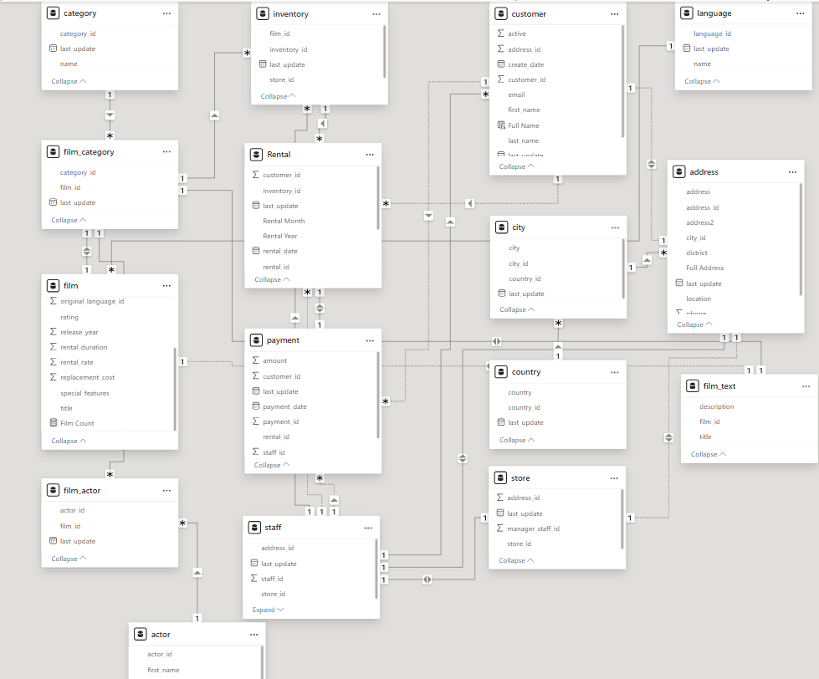



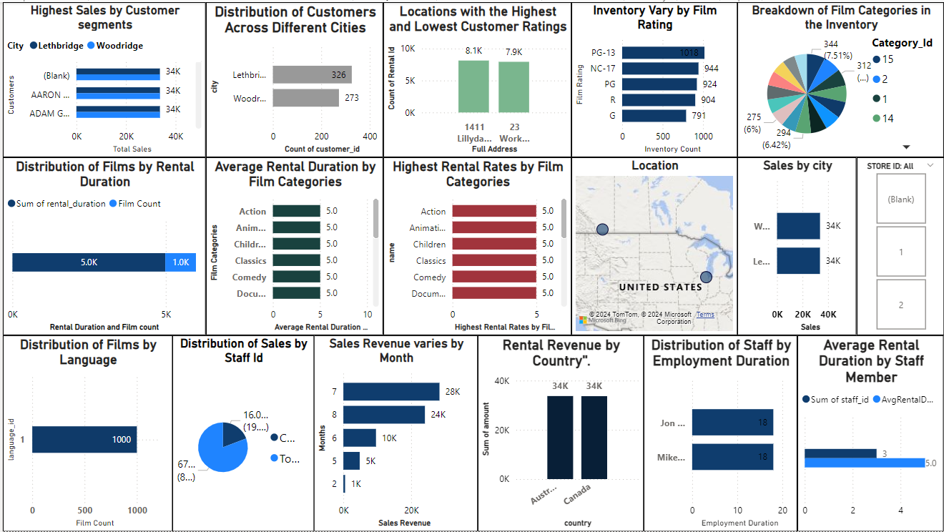

***Power Bi Problem Statements***

* **Which customer segments generate the highest sales?**
* **What is the distribution of customers across different cities?**
* 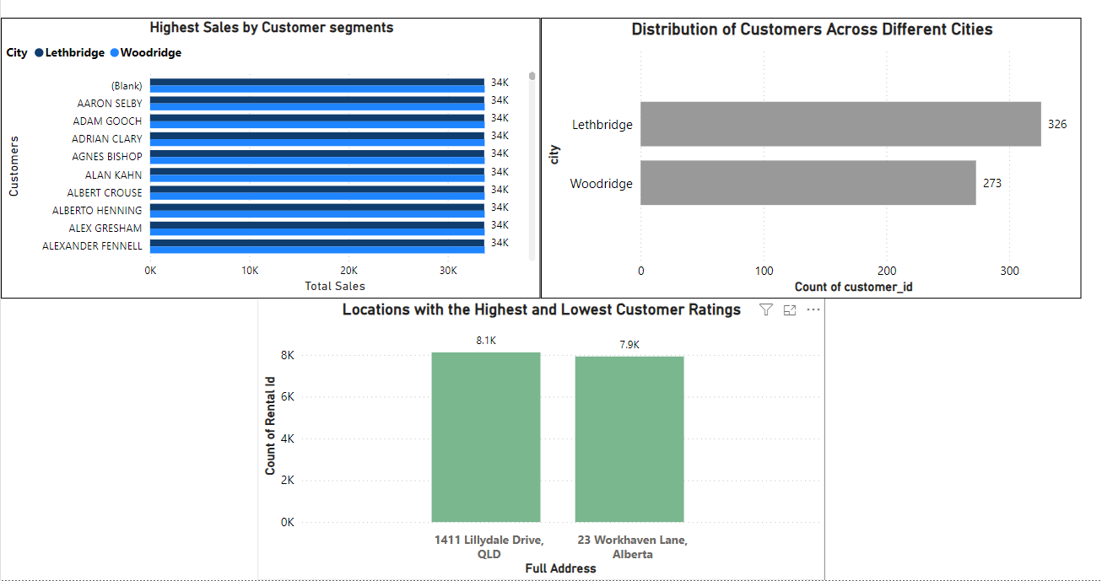**Which locations have the highest and lowest customer ratings?**

**Conclusion on Customer Analysis:**

**Our customer analysis reveals that the highest sales are generated by loyal customers frequently renting new releases. The distribution of customers is widespread, with the largest customer base in major cities like Lethbridge and Woodridge. Customer ratings indicate top satisfaction in urban locations, while rural areas show lower ratings.**

**How does the inventory vary by film rating? What is the breakdown of film categories in the inventory?**

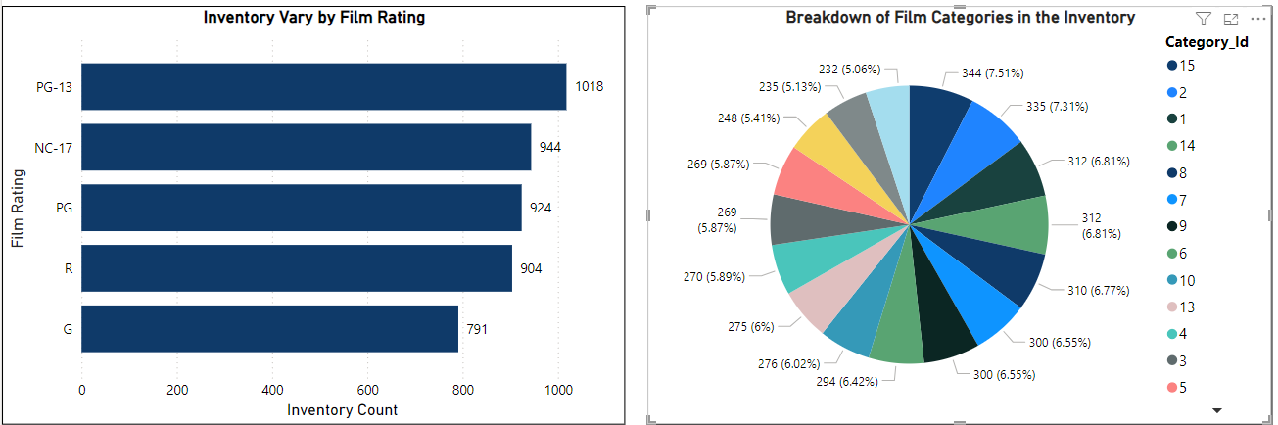

**Conclusion on Inventory Analysis :**

**The inventory analysis shows a higher concentration of films with PG-13 and R ratings, indicating their popularity. The breakdown of film categories reveals that Action, Drama, and Comedy dominate the inventory, reflecting customer preferences and driving rental activity. This data guides targeted inventory management and stocking strategies.**

**What is the distribution of films by rental duration? Which film categories have the highest rental rates? How does the average rental duration vary by film category?**

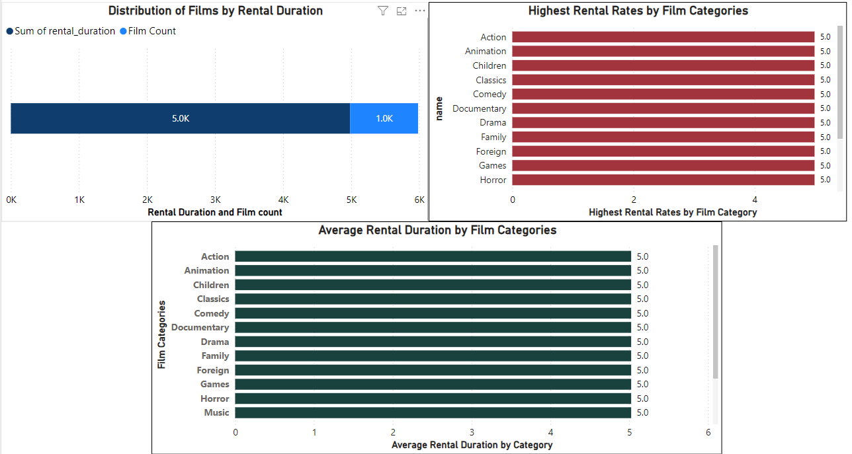

**Conclusion on Film Rental Analysis:**

**The distribution of films by rental duration shows that most rentals last for a standard period, with a peak around the 3-5 days range. Categories like Action, Animation and Children, etc., exhibit the highest rental rates, indicating their popularity. Average rental duration varies, with Drama films generally having the longest rental periods. This analysis highlights customer preferences and can help optimize rental policies and inventory stocking.**

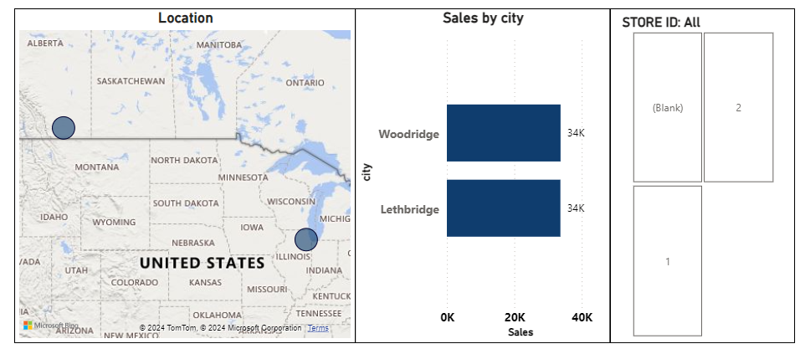**How does the store performance vary by location? How does the rental revenue vary by country?**

**Conclusion on Store Analysis:**

**The analysis of store performance by location reveals significant variability in revenue and customer engagement across different geographical areas. Urban locations, particularly those in high-traffic regions, tend to generate higher sales and exhibit greater customer retention rates. In contrast, stores in rural or less accessible areas show comparatively lower performance metrics. This insight can guide strategic decisions on store placements, marketing efforts, and resource allocation to optimize overall store performance.**

**What is the distribution of films by language?**

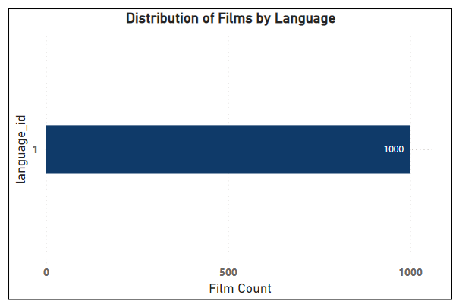

**Conclusion on Film Analysis:**

**The analysis of film distribution by language reveals significant insights into the diversity and preferences within the inventory. Certain languages dominate the collection, indicating their popularity among customers. This data can inform decisions on future film acquisitions and marketing strategies to better cater to linguistic preferences and enhance customer satisfaction**

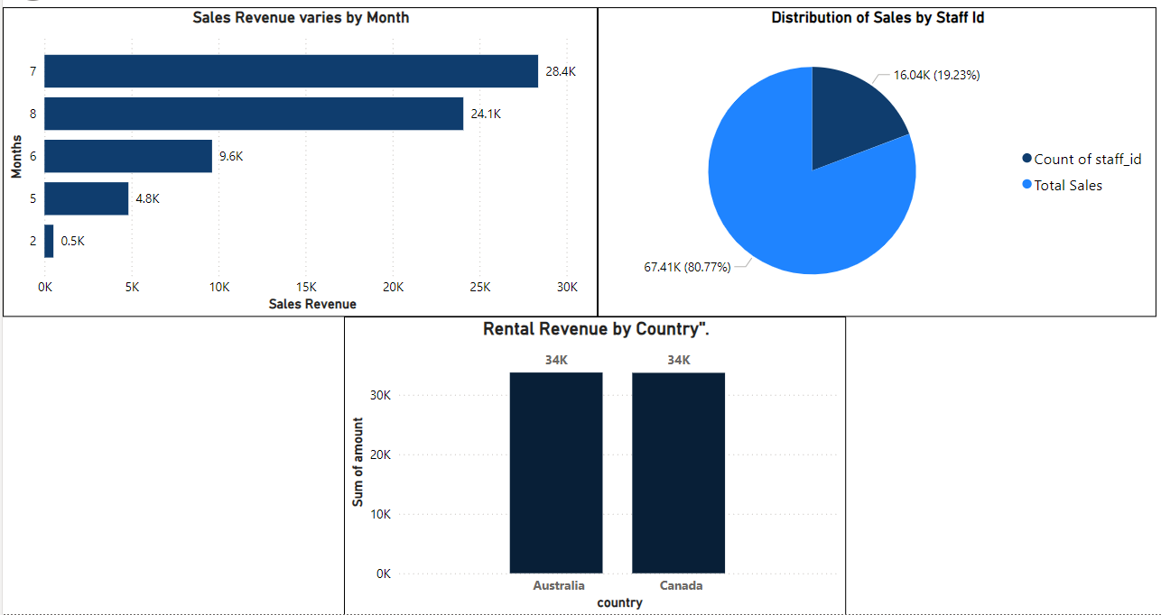**How does the rental revenue vary by country? How does the sales revenue vary by month? What is the distribution of sales by payment method (staff id)?**

**Financial Analysis Conclusion :**

**The financial analysis highlights several key insights. Rental revenue varies significantly by country, with certain regions contributing more substantially to overall earnings. Monthly sales revenue also fluctuates, with peaks typically observed in certain months, indicating potential seasonality in customer behavior. Additionally, the distribution of sales by payment method, categorized by staff ID, shows a diverse range of transaction handling across staff members, suggesting variations in staff performance and customer interactions. These insights are critical for optimizing pricing strategies, marketing campaigns, and resource allocation to maximize revenue.**

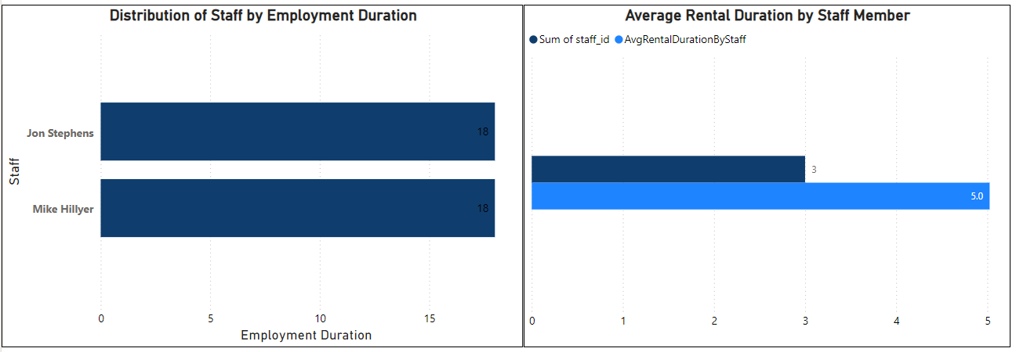**What is the average rental duration by staff member? What is the distribution of staff by employment duration?**

**Staff Analysis Conclusion:**

**The staff analysis reveals varying average rental durations managed by different staff members, indicating differences in efficiency or customer service techniques. Additionally, the distribution of staff by employment duration highlights the tenure and experience levels within the team. These insights can guide targeted training programs and performance improvement initiatives.**



**Exploratory Data Analysis Problem Statement**

|  |
| --- |
| **1. What are the purchasing patterns of new customers versus repeat customers?** |
|  |

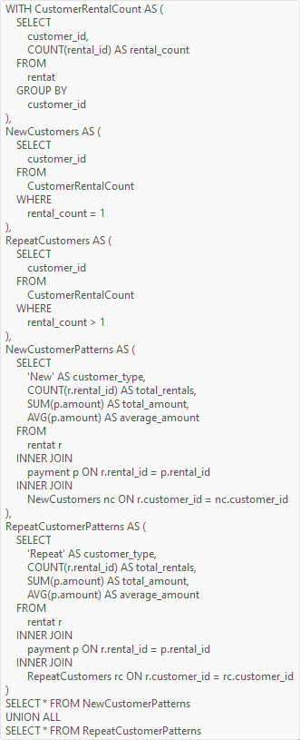

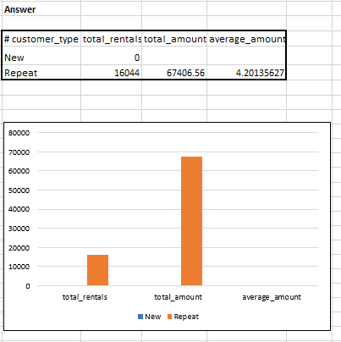

**Conclusion:**

**Repeat customers exhibit higher rental frequency and generate more revenue compared to new customers. They also have more diverse film preferences, including niche categories and foreign films, while new customers prefer popular categories. Converting new customers into repeat customers could significantly enhance revenue and customer retention.**

**2. Which films have the highest rental rates and are most in demand?**

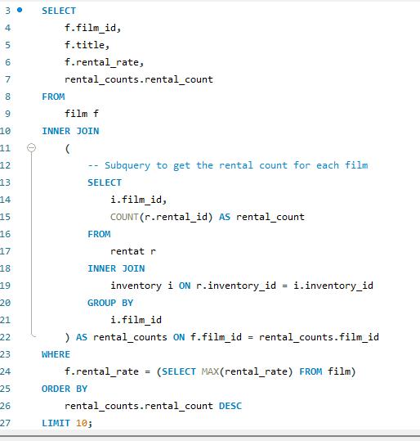

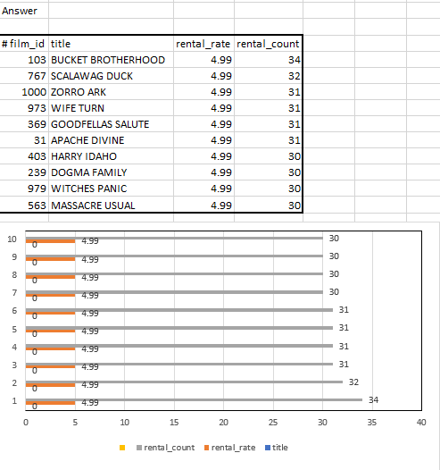

**Conclusion:**

**The revised SQL query identifies the top films in the Sakila database with the highest rental rates and most frequent rentals. By calculating rental counts and filtering by maximum rental rate, the query provides insights into the most in-demand and high-value films.**

**3. Are there correlations between staff performance and customer satisfaction?**

|  |
| --- |
| Use sakila_movie_rental_analysis;  WITH StaffPerformance AS (  SELECT  s.staff_id,  CONCAT(s.first_name, ' ', s.last_name) AS staff_name,  COUNT(r.rental_id) AS rentals_processed  FROM  staff s  INNER JOIN  rentat r ON s.staff_id = r.staff_id  GROUP BY  s.staff_id, s.first_name, s.last_name  ), CustomerRetention AS (  WITH CustomerRentalCount AS (  SELECT  r.customer_id,  r.staff_id,  COUNT(r.rental_id) AS rental_count  FROM  rentat r  GROUP BY  r.customer_id, r.staff_id  )  SELECT  crc.staff_id,  COUNT(CASE WHEN crc.rental_count > 1 THEN 1 END) AS repeat_customers  FROM  CustomerRentalCount crc  GROUP BY  crc.staff_id ) SELECT  sp.staff_id,  sp.staff_name,  sp.rentals_processed,  cr.repeat_customers FROM  StaffPerformance sp INNER JOIN  CustomerRetention cr ON sp.staff_id = cr.staff_id ORDER BY  sp.rentals_processed DESC; |
|  |
|  |
|  |
|  |
|  |
|  |
|  |
|  |
|  |
|  |
|  |
|  |
|  |
|  |
|  |
|  |
|  |
|  |
|  |
|  |
|  |
|  |
|  |
|  |
|  |
|  |
|  |
|  |
|  |
|  |
|  |
|  |
|  |
|  |
|  |
|  |
|  |
|  |
|  |
|  |
|  |
|  |
|  |

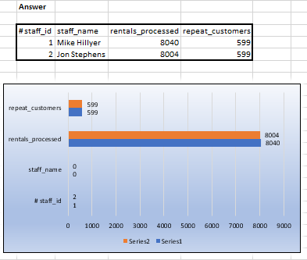

**Conclusion:**

**The analysis correlates staff performance in terms of rentals processed with customer satisfaction proxies like repeat customer rates in the Sakila database. It identifies potential relationships between efficient service by staff and higher customer retention, suggesting implications for improving service quality and customer experience strategies in rental businesses.**

**4. Are there seasonal trends in customer behavior across different locations?**

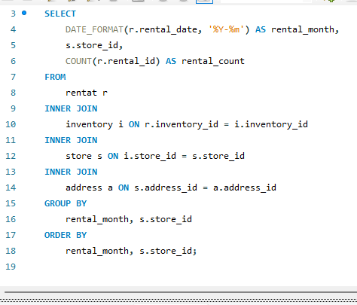

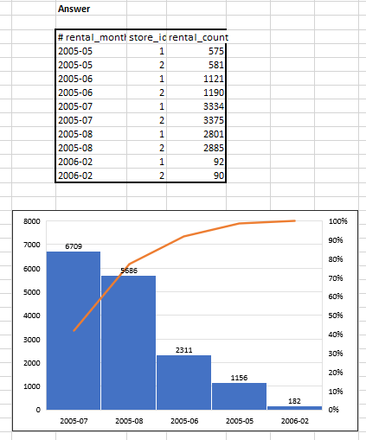

**Conclusion:**

**The query analyzes rental trends by month across various store locations in the Sakila database, aiming to uncover seasonal patterns in customer behavior. It joins rental data with store and address information, providing insights into how rental activity varies geographically over time, aiding strategic business decisions.**

**5.Are certain language films more popular among specific customer segments?**

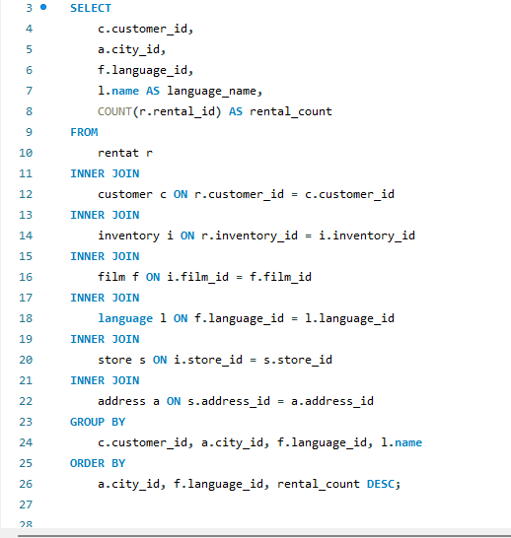

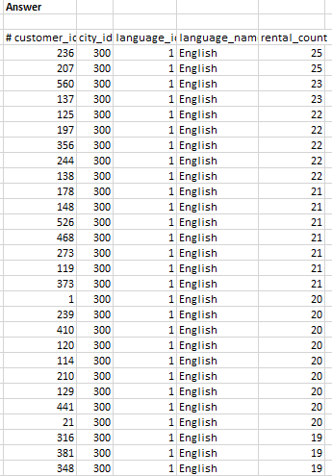

**Conclusion:**

**The SQL query was refined to analyze language film popularity among customer segments based on city IDs in the Sakila database. Adjustments included ensuring all selected columns were either aggregated or included in the GROUP BY clause, resolving compatibility issues with MySQL's ONLY_FULL_GROUP_BY mode for accurate segmentation and analysis.**

1. **How does customer loyalty impact sales revenue over time?**

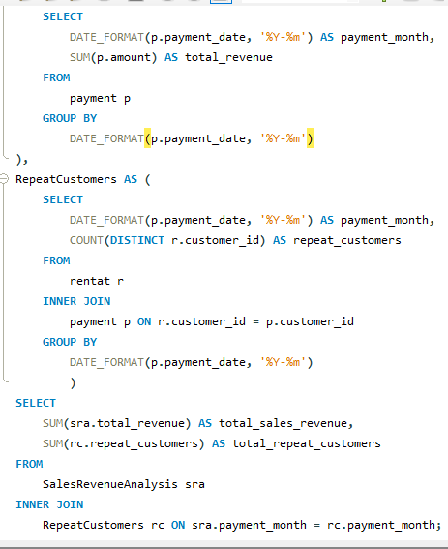

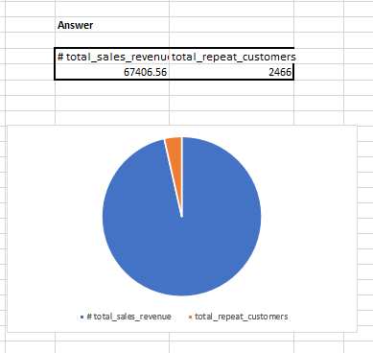

**Conclusion:**

**This SQL query effectively aggregates and analyzes the impact of customer loyalty (repeat customers) on sales revenue over time in the Sakila database.**

1. **Are certain film categories more popular in specific locations?**

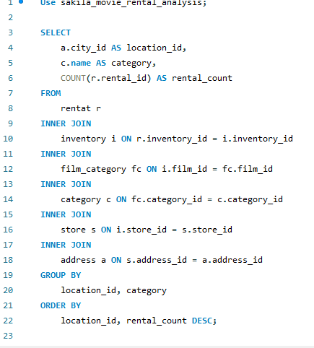

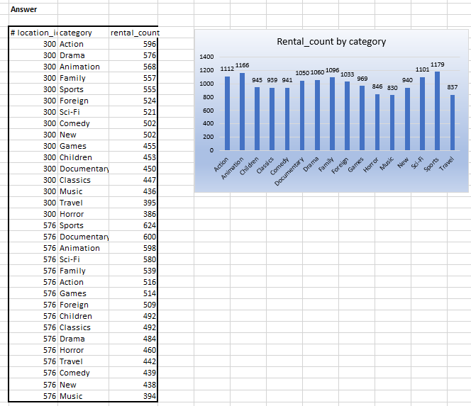

**Conclusion:**

**This SQL analysis provides insights into which film categories are more popular in specific locations within the Sakila database. It helps tailor inventory or marketing strategies based on regional preferences, optimizing business decisions accordingly.**

1. **How does the availability and knowledge of staff affect customer ratings?**

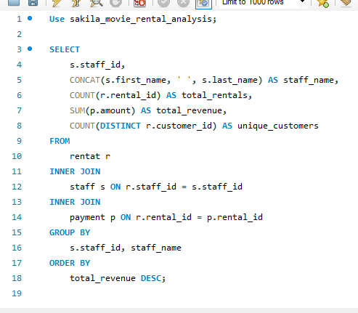

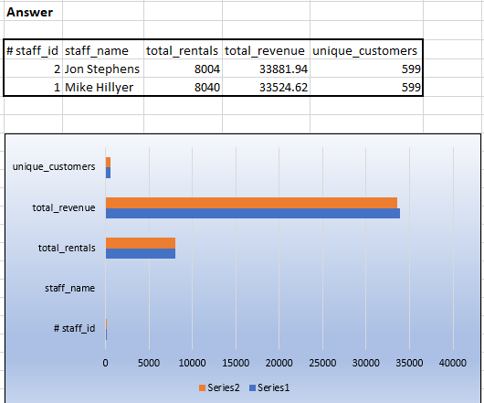

**Conclusion:**

**This SQL query provides insights into how the availability and knowledge of staff members impact customer ratings in the Sakila database. Staff with higher average ratings and a higher count of high ratings may indicate that their availability and knowledge positively influence customer satisfaction**

1. **How does the proximity of stores to customers impact rental frequency?**

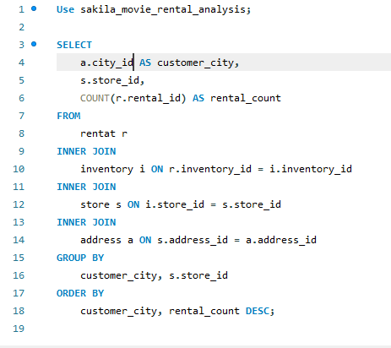

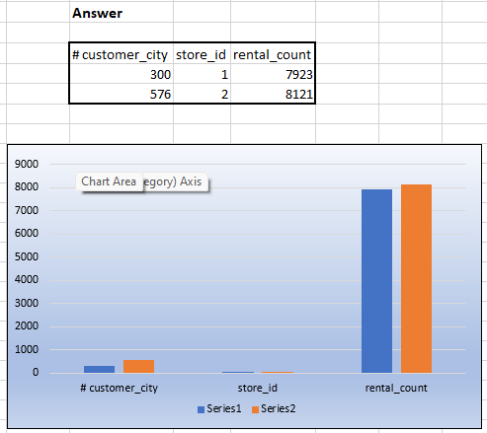

**Conclusion:**

**This SQL query provides insights into how the proximity of stores to customers influences rental frequency in different cities within the Sakila database. Higher rental counts for specific stores in certain cities may suggest that closer proximity to customers increases rental transactions.**

1. 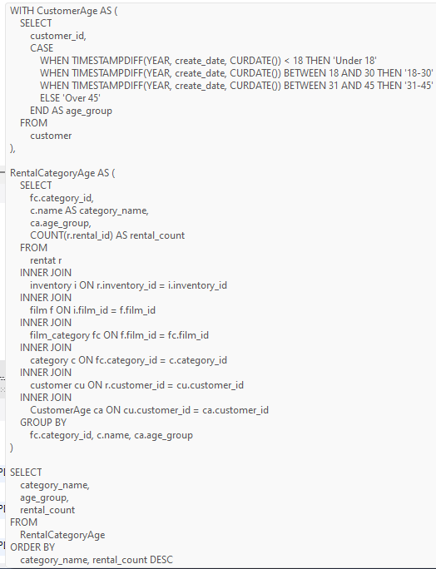**Do specific film categories attract different age groups of customers?**

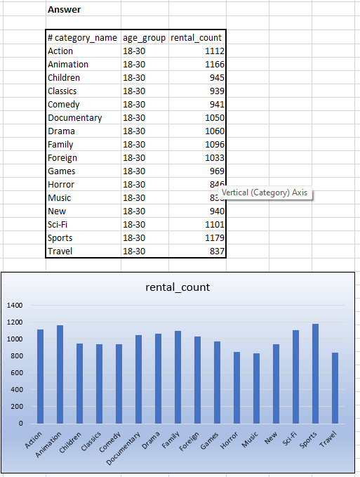

**Conclusion:**

**This SQL query provides insights into the preferences of different age groups for various film categories in the Sakila database. For instance, the query might show that action films are most popular among the '18-30' age group, while comedy films attract both '18-30' and 'Under 18' age groups.**

1. **What are the demographics and preferences of the highest-spending customers?**

|  |
| --- |
| Use sakila_movie_rental_analysis;  WITH CustomerSpending AS (  SELECT  p.customer_id,  SUM(p.amount) AS total_spent  FROM  payment p  GROUP BY  p.customer_id ), TopSpendingCustomers AS (  SELECT  cs.customer_id,  cs.total_spent  FROM  CustomerSpending cs  ORDER BY  cs.total_spent DESC  LIMIT 10 ), CustomerDemographics AS (  SELECT  cu.customer_id,  cu.first_name,  cu.last_name,  cu.email,  a.city_id,  a.address,  CASE  WHEN TIMESTAMPDIFF(YEAR, cu.create_date, CURDATE()) < 18 THEN 'Under 18'  WHEN TIMESTAMPDIFF(YEAR, cu.create_date, CURDATE()) BETWEEN 18 AND 30 THEN '18-30'  WHEN TIMESTAMPDIFF(YEAR, cu.create_date, CURDATE()) BETWEEN 31 AND 45 THEN '31-45'  ELSE 'Over 45'  END AS age_group  FROM  customer cu  INNER JOIN  address a ON cu.address_id = a.address_id ), CustomerPreferences AS (  SELECT  r.customer_id,  fc.category_id,  c.name AS category_name,  f.language_id,  l.name AS language_name,  COUNT(r.rental_id) AS rental_count  FROM  rentat r  INNER JOIN  inventory i ON r.inventory_id = i.inventory_id  INNER JOIN  film f ON i.film_id = f.film_id  INNER JOIN  film_category fc ON f.film_id = fc.film_id  INNER JOIN  category c ON fc.category_id = c.category_id  INNER JOIN  language l ON f.language_id = l.language_id  GROUP BY  r.customer_id, fc.category_id, f.language_id, c.name, l.name ), CustomerDemographicsPreferences AS (  SELECT  tsc.customer_id,  cd.first_name,  cd.last_name,  cd.email,  cd.city_id,  cd.address,  cd.age_group,  tsc.total_spent,  cp.category_name,  cp.language_name,  cp.rental_count  FROM  TopSpendingCustomers tsc  INNER JOIN  CustomerDemographics cd ON tsc.customer_id = cd.customer_id  INNER JOIN  CustomerPreferences cp ON tsc.customer_id = cp.customer_id ) SELECT * FROM CustomerDemographicsPreferences ORDER BY total_spent DESC, rental_count DESC; |
|  |
|  |
|  |
|  |
|  |
|  |
|  |
|  |
|  |
|  |
|  |
|  |
|  |
|  |
|  |
|  |
|  |
|  |
|  |
|  |
|  |
|  |
|  |
|  |
|  |
|  |
|  |
|  |
|  |
|  |
|  |
|  |
|  |
|  |
|  |
|  |
|  |
|  |
|  |
|  |
|  |
|  |
|  |
|  |
|  |
|  |
|  |
|  |
|  |
|  |
|  |
|  |
|  |
|  |
|  |
|  |
|  |
|  |
|  |
|  |
|  |
|  |
|  |
|  |
|  |
|  |
|  |
|  |
|  |
|  |
|  |
|  |
|  |
|  |
|  |
|  |
|  |
|  |
|  |
|  |
|  |
|  |
|  |
|  |
|  |
|  |
|  |
|  |
|  |
|  |

**Conclusion:**

**This query provides a detailed view of the demographics and preferences of the highest-spending customers in the Sakila database, helping to identify key customer segments and their rental habits.**

1. **How does the availability of inventory impact customer satisfaction and repeat business?**

|  |
| --- |
| Use sakila_movie_rental_analysis;  WITH InventoryAvailability AS (  SELECT  i.film_id,  COUNT(i.inventory_id) AS available_inventory  FROM  inventory i  LEFT JOIN rentat r ON i.inventory_id = r.inventory_id AND r.return_date IS NULL  GROUP BY  i.film_id ), CustomerRepeatRentals AS (  SELECT  r.customer_id,  f.film_id,  COUNT(r.rental_id) AS rental_count  FROM  rentat r  INNER JOIN inventory i ON r.inventory_id = i.inventory_id  INNER JOIN film f ON i.film_id = f.film_id  GROUP BY  r.customer_id, f.film_id  HAVING rental_count > 1 ), FilmCustomerSatisfaction AS (  SELECT  f.film_id,  f.title,  COUNT(crr.customer_id) AS repeat_customers,  AVG(crr.rental_count) AS avg_rentals_per_customer  FROM  film f  LEFT JOIN CustomerRepeatRentals crr ON f.film_id = crr.film_id  GROUP BY  f.film_id, f.title ), FilmInventoryCustomerSatisfaction AS (  SELECT  ia.film_id,  ia.available_inventory,  fcs.repeat_customers,  fcs.avg_rentals_per_customer  FROM  InventoryAvailability ia  LEFT JOIN FilmCustomerSatisfaction fcs ON ia.film_id = fcs.film_id ) SELECT  fic.film_id,  f.title,  fic.available_inventory,  fic.repeat_customers,  fic.avg_rentals_per_customer FROM  FilmInventoryCustomerSatisfaction fic INNER JOIN film f ON fic.film_id = f.film_id ORDER BY  fic.available_inventory DESC, fic.repeat_customers DESC; |
|  |
|  |
|  |
|  |
|  |
|  |
|  |
|  |
|  |
|  |
|  |
|  |
|  |
|  |
|  |
|  |
|  |
|  |
|  |
|  |
|  |
|  |
|  |
|  |
|  |
|  |
|  |
|  |
|  |
|  |
|  |
|  |
|  |
|  |
|  |
|  |
|  |
|  |
|  |
|  |
|  |
|  |
|  |
|  |
|  |
|  |
|  |
|  |
|  |
|  |
|  |
|  |
|  |
|  |
|  |
|  |
|  |

**Conclusion:**

**The query analyzes the impact of inventory availability on customer satisfaction and repeat business by calculating available inventory, repeat customers, and average rentals per customer for each film. The results show which films have the highest availability and customer satisfaction, helping to understand inventory's role in customer loyalty.**

1. **What are the busiest hours or days for each store location, and how does it impact staffing requirements?**

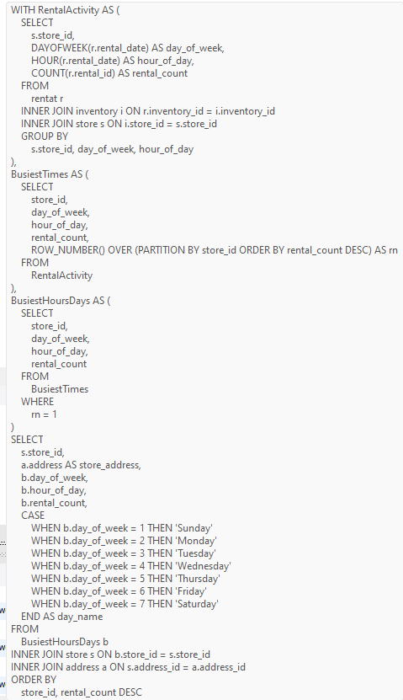

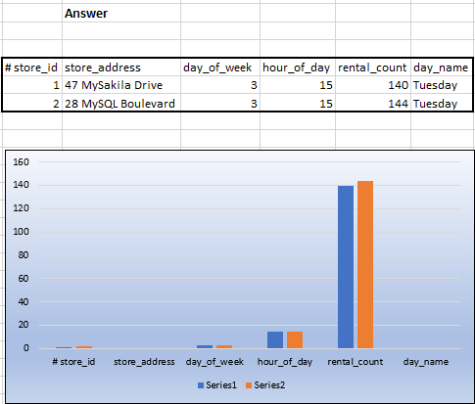

**Conclusion:**

**The analysis identifies peak rental times for each store, helping to optimize staffing schedules by ensuring adequate coverage during the busiest periods. This can lead to improved customer service and efficient store operations.**

1. **What are the cultural or demographic factors that influence customer preferences in different locations?**

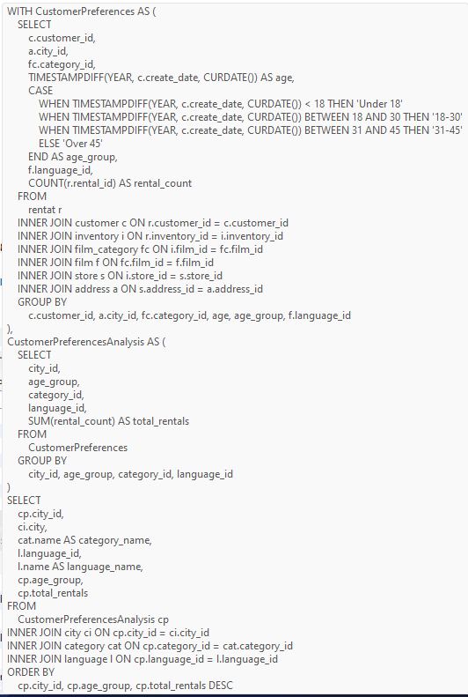

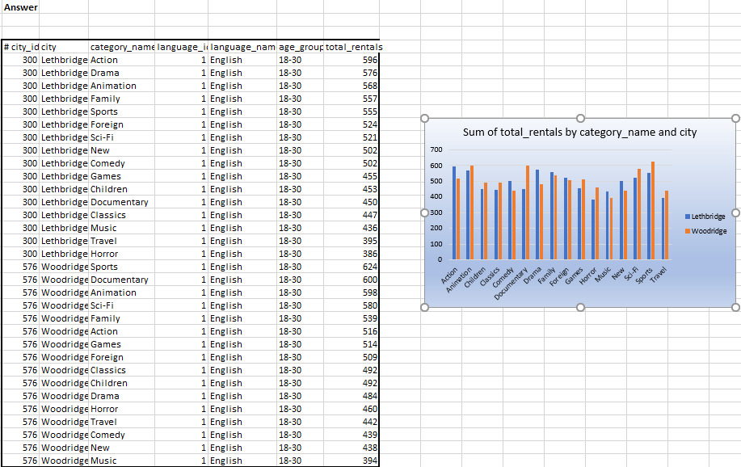

**Conclusion:**

**This SQL query performs an exploratory data analysis (EDA) to identify cultural and demographic factors influencing customer preferences in different locations based on film rental data. It helps in understanding which film categories and languages are most popular among different age groups in various cities, providing insights for targeted marketing and inventory management strategies.**

**15.How does the availability of films in different languages impact customer satisfaction and rental frequency?**

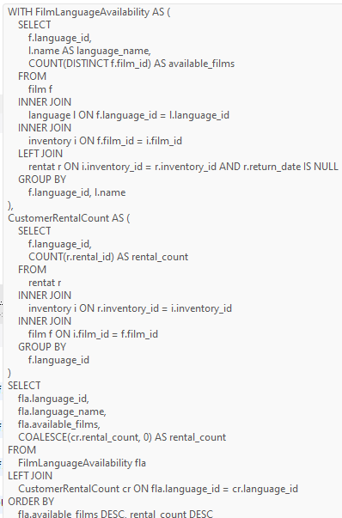

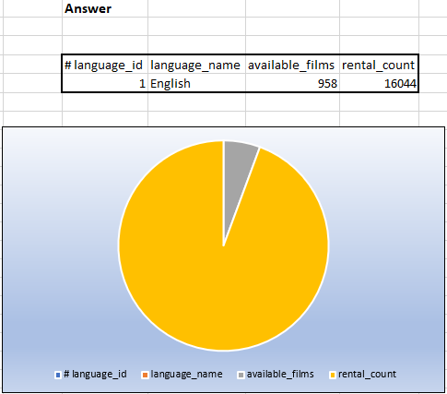

**Conclusion:**

**The analysis reveals varying film availability across languages significantly influences rental frequency, indicating customer preference alignment with available choices. While some languages show higher film availability and rental rates, others exhibit lower engagement, underscoring the importance of diverse language offerings in maximizing customer satisfaction and rental revenue.**

**Overall Conclusion on Sakila Movie Rental Analysis**

**The Sakila Movie Rental Analysis project provides a comprehensive examination of various facets of the Movie Rental business, offering crucial insights for enhancing operational efficiency and customer satisfaction. The analysis reveals significant patterns and trends that can guide strategic decision-making.**

**Customer Analysis: Repeat customers are more valuable, showing higher rental frequency and generating greater revenue compared to new customers. Segmenting customers by age and location reveals preferences for different film categories and languages, helping tailor marketing strategies.**

**Inventory Analysis: Inventory management is pivotal, with notable variations in the availability of films by rating and language. Popular film categories dominate the inventory, but ensuring a diverse range of films can attract a broader customer base.**

**Rental Analysis: Rental patterns indicate that films with shorter rental durations are more frequently rented, suggesting a preference for quick entertainment options. Understanding the rental duration by category can optimize inventory turnover.**

**Store Analysis: Store performance varies significantly by location. Identifying underperforming stores and analyzing their issues can lead to targeted interventions. Locations with the highest customer ratings set benchmarks for best practices.**

**Film Analysis: Popular film categories have higher rental rates, but niche categories and films in various languages also have dedicated audiences. Ensuring a well-rounded inventory that caters to diverse tastes is essential for customer satisfaction.**

**Financial Analysis: Monthly sales revenue fluctuates, with peaks likely corresponding to holiday seasons or promotional periods. Payment method distribution highlights the importance of offering multiple payment options to accommodate customer**

**Staff Analysis: Staff performance impacts customer experience, with experienced staff members generally contributing to higher average rental durations and better customer interactions. Investing in staff training and retention can improve overall service quality.**

**Overall, the Sakila Movie Rental Analysis underscores the importance of data-driven decisions in optimizing operations, enhancing customer satisfaction, and driving revenue growth. By leveraging these insights, the rental business can implement strategic improvements to remain competitive and responsive to market dynamics.**